|  |
| --- |
| **NAMA : Farhan Romdoni** |
| **NIM : 1207070044** |
| **KELAS : PCD TT** |
| **TUGAS KE-5** |

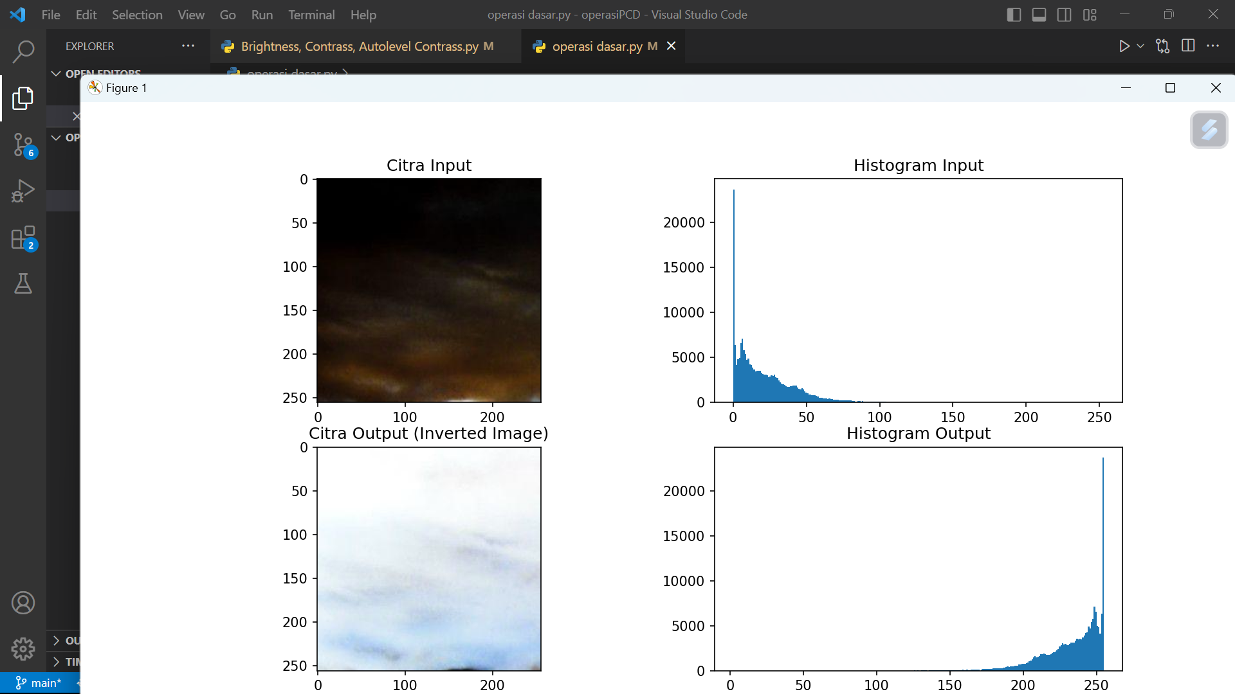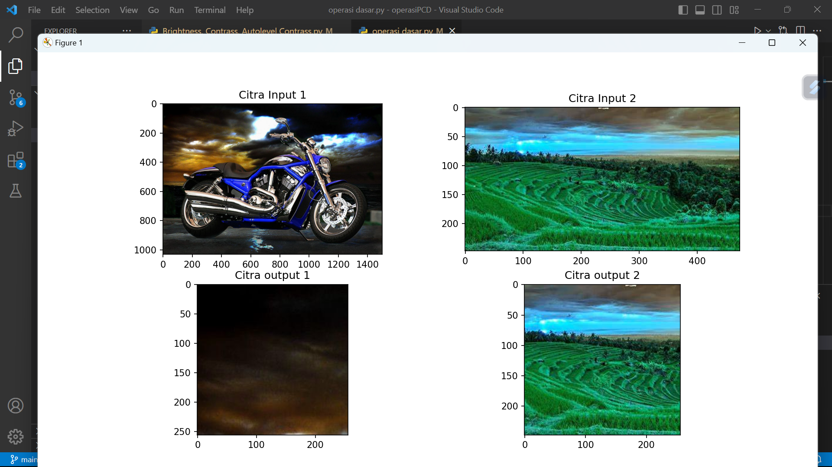

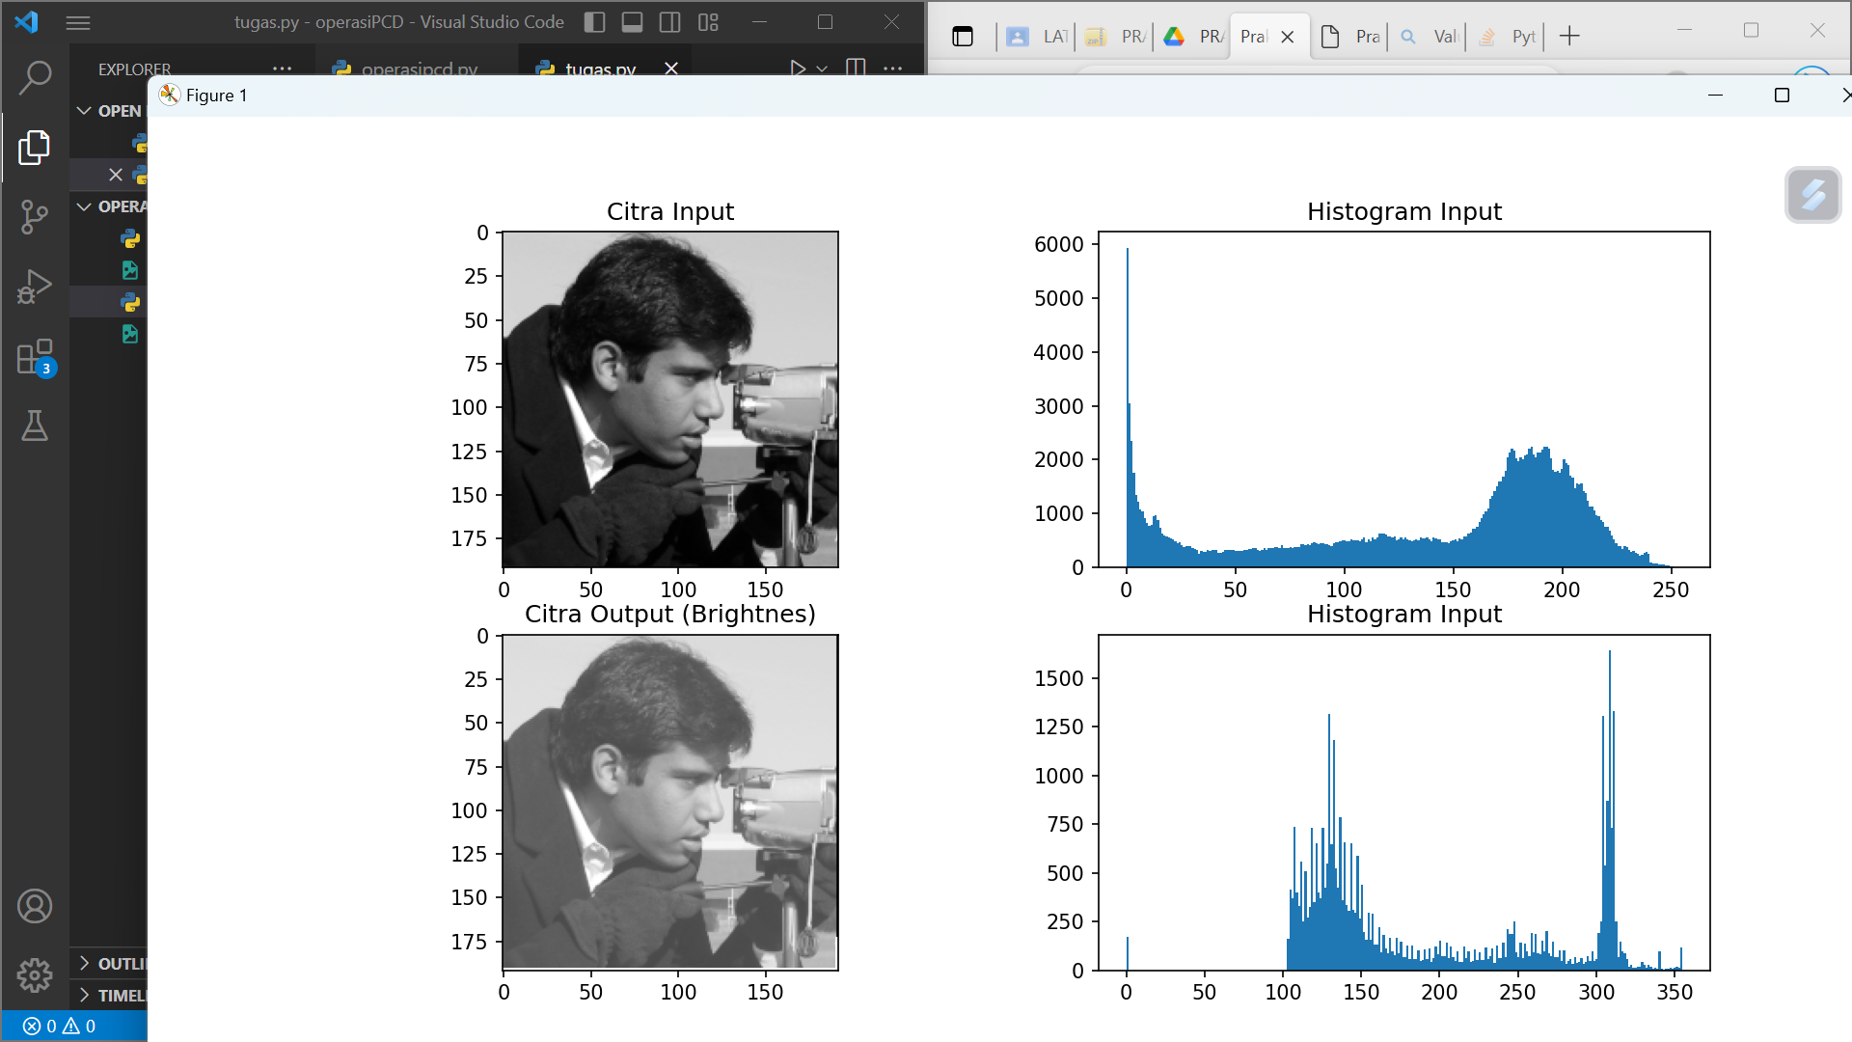

**Percobaan Brightness,Contrass,Autolevel contrass**

